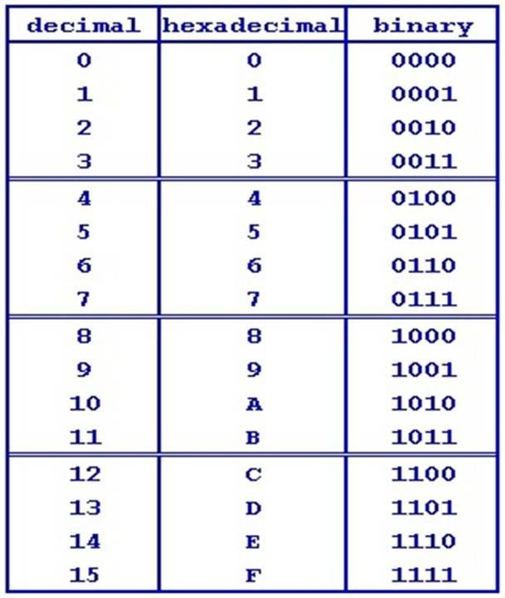Number Representations:

ob = binary

ox = hex

Easy way to convert from decimal to binary:

Ex: 14

1 🡨 3 🡨 7 🡨 14

1 1 1 0 🡪 0b1110 is binary for 14

binary to hex: 0b11100010 🡪 0xE2

look at 4 bits and convert the 4 bits into hex (makes sense since 4 bits can represent 15 numbers)

Two’s complement:

Ex: 0b10110010 (negative to positive)

01001101 🡨 convert all 0’s to 1

01001110 🡨 add 1 to result to get 2’s complement

Ex: 0b01001110 (positive to negative)

10110001 🡨 convert all 0’s to 1

10110010 🡨 add 1 to result